IMAP Server

📥 What is an IMAP Server?
# Source: AI Source: Provided by: [Data Path: Persons Table -> ID Column: 1, Name_En Column: Motasem Essam] -> From: [Chatgpt (GPT‑5 Mini)] on [1/21/2026]
An IMAP server is a mail server that uses the Internet Message Access Protocol (IMAP) to let you access and manage your emails directly on the server — without downloading or deleting them by default.
💡 With IMAP, your email client synchronizes with the server, so you can read, organize, and delete emails from multiple devices — and they all stay in sync.

what mean of manage your emails directly on the server
# Source: AI Source: Provided by: [Data Path: Persons Table -> ID Column: 1, Name_En Column: Motasem Essam] -> From: [Chatgpt (GPT‑5 Mini)] on [1/21/2026]
It means that when you use IMAP, all your email actions — reading, deleting, moving, organizing — happen on the email provider’s server, not just on your device.

🧠 In Simple Terms:
# Source: AI Source: Provided by: [Data Path: Persons Table -> ID Column: 1, Name_En Column: Motasem Essam] -> From: [Chatgpt (GPT‑5 Mini)] on [1/21/2026]
When you use IMAP, your email client (like Gmail app, Outlook, Apple Mail) is like a remote control for your inbox on the server.

Here's what this lets you do on the server:
# Source: AI Source: Provided by: [Data Path: Persons Table -> ID Column: 1, Name_En Column: Motasem Essam] -> From: [Chatgpt (GPT‑5 Mini)] on [1/21/2026]
- 📖 Read emails (the original stays on the server)
- 🗑️ Delete emails (they’re deleted from the server, not just your app)
- 🗂️ Move emails to folders (e.g., from Inbox to "Work")
- 🚩 Mark as read/unread or starred
- 🔄 See changes instantly on all devices (because the server is the source of truth)

📱 Example:
# Source: AI Source: Provided by: [Data Path: Persons Table -> ID Column: 1, Name_En Column: Motasem Essam] -> From: [Chatgpt (GPT‑5 Mini)] on [1/21/2026]
Imagine you log into Gmail on your phone and delete an email.
- With IMAP: It disappears from your inbox on your laptop too — because it was deleted on the server
- With POP3: It only disappears locally — and the original stays on the server unless explicitly removed

📁 Visual:
# Source: AI Source: Provided by: [Data Path: Persons Table -> ID Column: 1, Name_En Column: Motasem Essam] -> From: [Chatgpt (GPT‑5 Mini)] on [1/21/2026]
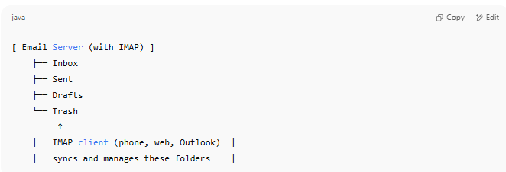

[ Email Server (with IMAP) ]
├── Inbox
├── Sent
├── Drafts
└── Trash
↑
| IMAP client (phone, web, Outlook) |
| syncs and manages these folders |

✅ Summary:
# Source: AI Source: Provided by: [Data Path: Persons Table -> ID Column: 1, Name_En Column: Motasem Essam] -> From: [Chatgpt (GPT‑5 Mini)] on [1/21/2026]
"Manage emails directly on the server" means:
- Your app is just a mirror of your inbox
- You don’t need to download or move emails manually
- You can use multiple devices and keep everything in sync

🧠 Real-life comparison:
# Source: AI Source: Provided by: [Data Path: Persons Table -> ID Column: 1, Name_En Column: Motasem Essam] -> From: [Chatgpt (GPT‑5 Mini)] on [1/21/2026]
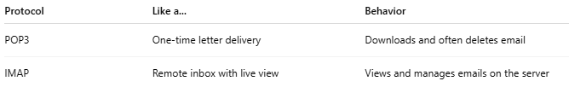

Protocol | Like a... | Behavior
POP3 | One-time letter delivery | Downloads and often deletes email
IMAP | Remote inbox with live view | Views and manages emails on the server

✅ IMAP Server Functions:
# Source: AI Source: Provided by: [Data Path: Persons Table -> ID Column: 1, Name_En Column: Motasem Essam] -> From: [Chatgpt (GPT‑5 Mini)] on [1/21/2026]
- ✅ Shows your inbox in real time
- ✅ Keeps all folders (Inbox, Sent, Drafts) in sync across devices
- ✅ Lets you move, delete, flag messages from any device
- ✅ Downloads message only when opened (saves space)

📨 Example IMAP Server Settings:
# Source: AI Source: Provided by: [Data Path: Persons Table -> ID Column: 1, Name_En Column: Motasem Essam] -> From: [Chatgpt (GPT‑5 Mini)] on [1/21/2026]
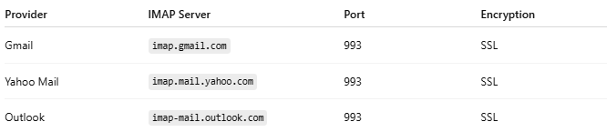

Provider | IMAP Server | Port | Encryption
Gmail | imap.gmail.com | 993 | SSL
Yahoo Mail | imap.mail.yahoo.com | 993 | SSL
Outlook | imap-mail.outlook.com | 993 | SSL

🆚 IMAP vs POP3
# Source: AI Source: Provided by: [Data Path: Persons Table -> ID Column: 1, Name_En Column: Motasem Essam] -> From: [Chatgpt (GPT‑5 Mini)] on [1/21/2026]
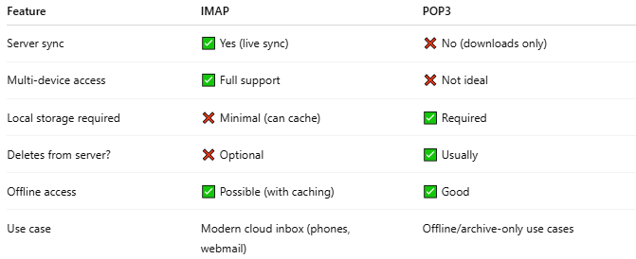

Feature | IMAP | POP3
Server sync | ✅ Yes (live sync) | ❌ No (downloads only)
Multi-device access | ✅ Full support | ❌ Not ideal
Local storage required | ❌ Minimal (can cache) | ✅ Required
Deletes from server? | ❌ Optional | ✅ Usually
Offline access | ✅ Possible (with caching) | ✅ Good
Use case | Modern cloud inbox (phones, webmail) | Offline/archive-only use cases

🧪 Use Cases for IMAP:
# Source: AI Source: Provided by: [Data Path: Persons Table -> ID Column: 1, Name_En Column: Motasem Essam] -> From: [Chatgpt (GPT‑5 Mini)] on [1/21/2026]
- You check email on your phone + laptop + web
- You use Gmail or Outlook on multiple devices
- You want to keep messages on the server and not lose them

🔁 Sample flow (IMAP in mail client):
# Source: AI Source: Provided by: [Data Path: Persons Table -> ID Column: 1, Name_En Column: Motasem Essam] -> From: [Chatgpt (GPT‑5 Mini)] on [1/21/2026]
- You open Outlook or Apple Mail.
- It logs in to imap.gmail.com with your credentials.
- It fetches a list of messages from the server.
- You click on a message → it’s downloaded on-demand.

✅ Summary
# Source: AI Source: Provided by: [Data Path: Persons Table -> ID Column: 1, Name_En Column: Motasem Essam] -> From: [Chatgpt (GPT‑5 Mini)] on [1/21/2026]
Role | Server Type | Used For
SMTP | Outgoing | Sending emails
POP3 | Incoming | One-time download
IMAP | Incoming | Full server sync

